Connections

This document includes the documentation about the electrical components and connections of the project.

An overview of all connections is shown in the diagram below. There are five subsystems:

The actuation system includes 3 actuators and their corresponding motor drivers. Each motor is specifically chosen to meet the mechanical requirements of the landing platform. The power requirements and outputs of each motor is controlled by the motor drivers which receive signals from the Raspberry Pi.

The inertial measurement unit system only includes 2 IMU sensors which are essential to provide inputs for the control algorithm. The first IMU ensures the top platform is flat while the second IMU ensures the platform does not exceed its rotational limit which could cause damage.

The detection system mainly includes the camera which tracks the Aruco markers and provides input as coordinates to guide the landing platform. Additionally, an ultrasonic sensor is utilised to validate the vertical distance of the platform to the drone and is the trigger for the catch mechanism. The servo motor rotates when triggered and releases the spring-loaded top platform and turns on the electromagnet.

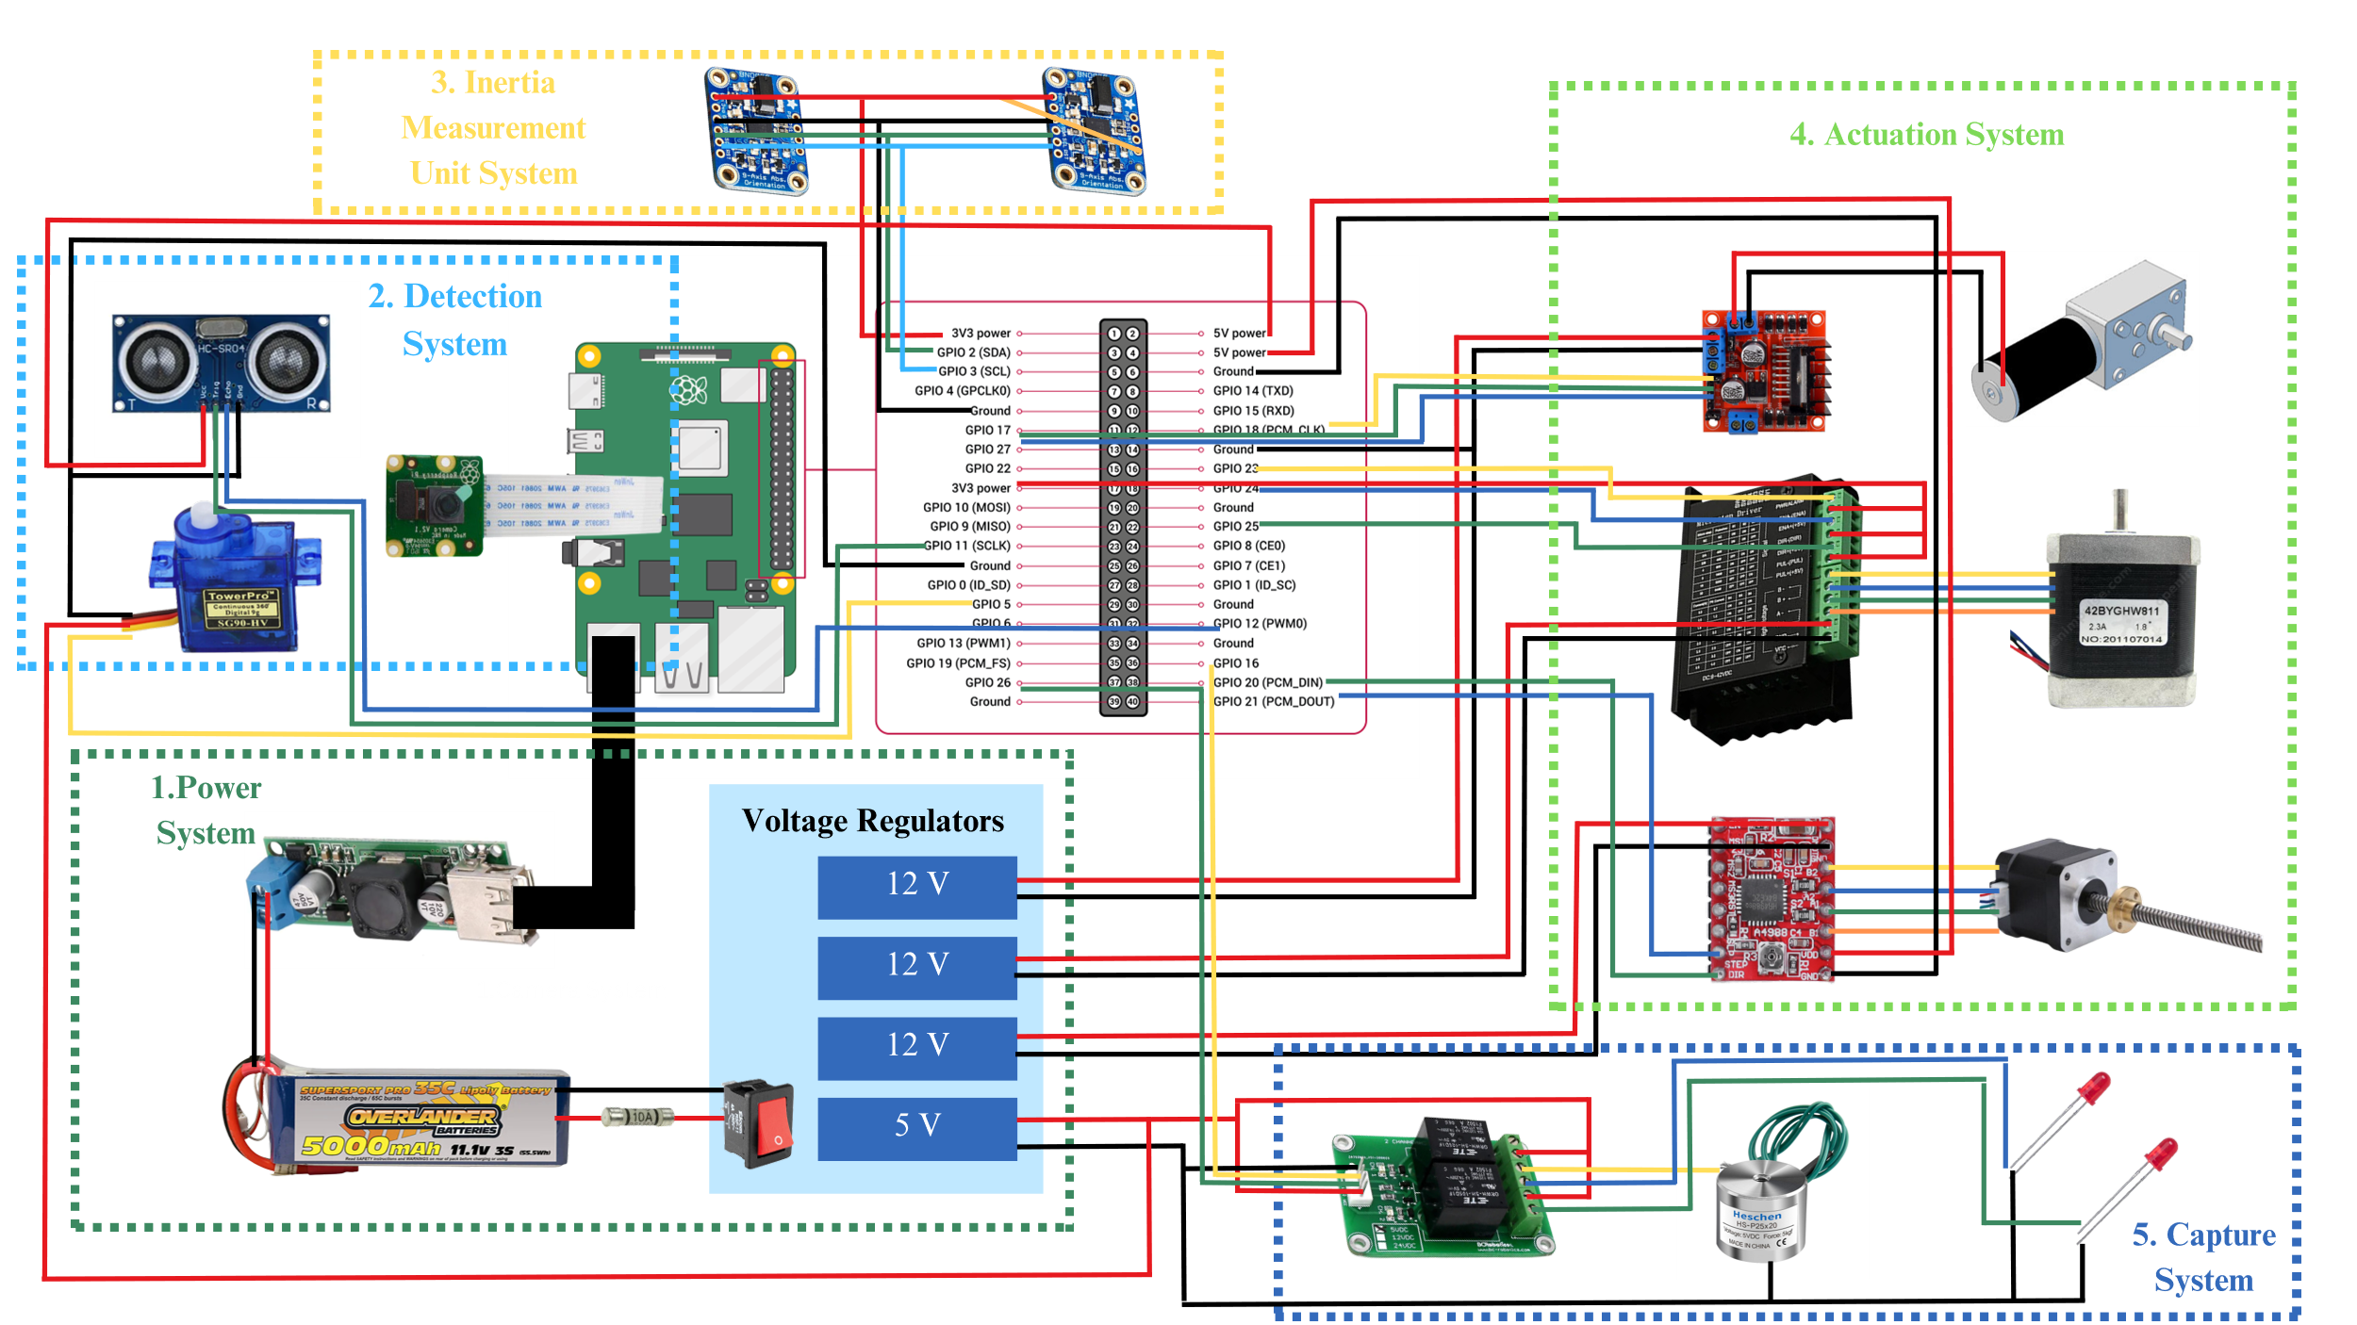

The capture system consists of the electromagnet which is responsible for attracting and keeping the drone attached to the top platform. It is controlled by a relay that receives signals from the Raspberry Pi. Additionally, 2 LEDs are used to indicate the status of the landing platform during operations.

The power system provides sufficient power for all the electronic components in the project. A designated buck convertor is used to provide 5 V to the RPI with USB port adaptors for connection. A strip board consisting of three 12 V and one 5 V voltage regulator powers the three actuators and additional components such as the electromagnet. The battery life is calculated to be 35 minutes during operation and 2 hours of idle condition.

# Connections to Raspberry Pi GPIO

The diagram below shows how the components are connected to the GPIO pins of the Raspberry Pi.

Figure 1. Connections of electronics to Raspberry Pi.